Juniper

Software Version: 1.0

Contents

1 Introduction 3-4

1.1 Purpose 3-4

1.2 Juniper Module 3-4

1.3 Revision history 3-4

1.4 Intended audience and reading suggestions 3-4

1.5 Technical project stakeholders 3-4

1.6 Objectives 3-4

1.7 References 3-5

2 Server Configurations 3-6

2.1 Server 1 (Micro Services – Frontend and Backend) 3-6

2.1.1 Roles, Features, and Packages 3-6

2.1.2 Configuration 3-6

2.1.3 Software Installations 3-6

2.2 Server 2 (Scheduler Host) 3-10

2.2.1 Roles, Features, and Packages 3-10

2.2.2 Configuration 3-10

2.2.3 Software Installations 3-10

2.3 Server 3 (Middleware) 3-10

2.3.1 Roles, Features, and Packages 3-10

2.3.2 Configuration 3-11

2.3.3 Software Installations 3-11

2.4 Server 4 (Database) 3-16

2.4.1 Roles, Features, and Packages 3-16

2.4.2 Configuration 3-17

2.4.3 Software Installations 3-17

2.4.4 Feed in the path for Oracle base and Software Location. 3-24

3 Other Prerequisites 3-36

4 Testing the Installation 3-37

5 Glossary 3-38

# Introduction

## Purpose

The purpose of this is to describe in technical terms the steps necessary to install the software and make it operational.

## Juniper Module

This module of Juniper consists of all relevant microservices responsible for migrating a File from a Linux premises to Google Cloud Storage.

## Revision history

The Revision history table shows the date, changes, and authors who have worked on this document.

| Version/Change request number | Version date | Description of changes | Author |
| --- | --- | --- | --- |
| 1.0 | 16/03/2019 | First Draft | To be filled… |

## Intended audience and reading suggestions

This is intended to be used by technical stakeholders of the project who will be responsible for planning, performing, or maintaining the installation or deployment, such as the Systems Administrator, Chief Information Officer (CIO), Analysts, or Developers.

It is intended that stakeholders and software support personnel can read this document and coordinate their efforts in the installation/deployment of the application.

## Technical project stakeholders

This section provides a list of all known stakeholders with an interest in the project.

| Name | E-mail address | Phone | Role |
| --- | --- | --- | --- |
|  |  |  | Owner |
|  |  |  | Lead Developer |
|  |  |  | Systems Administrator |

To be filled..

## Objectives

Juniper is an Open source tool which establishes Industry standards for Enterprise grade secure and scaling to Cloud platform enabling community based enrichment of data services using Micro-services based architecture at low cost.

## References

Refer the below links for installations of the following software/tools

| Reference No. | Document | Tools(s) |
| --- | --- | --- |
| REF-1 | <https://nifi.apache.org/> | Apache Nifi |
| REF-2 | <https://kafka.apache.org/downloads> | Kafka |
| REF-3 | <https://www.linode.com/docs/development/java/how-to-deploy-spring-boot-applications-nginx-ubuntu-16-04/> | Java |
| REF-4 | <https://www.linode.com/docs/development/java/how-to-deploy-spring-boot-applications-nginx-ubuntu-16-04/> | Spring Boot |
| REF-5 | <https://tecadmin.net/install-python-2-7-on-centos-rhel/> | Python |
| REF-6 | <https://www.tecmint.com/install-oracle-database-12c-on-centos-7/> | Oracle |
| REF-7 | <https://www.linode.com/docs/development/java/how-to-deploy-spring-boot-applications-nginx-ubuntu-16-04/> | Maven |

# Server Configurations

## Server 1 (Micro Services – Frontend and Backend)

Installation of this product is supported on the following operation systems and versions:

* RHEL 7

### Roles, Features, and Packages

**Packages**

The following software packages must be installed on the operating system prior to installation of the software:

* Unzip
* wget

### Configuration

Server Configuration:

* Virtual Cores – 4
* RAM – 15 GB

Authentication

* SSH
* SFTP

Server Network Configuration

* TCP/IP should be allowed
* Firewall Allow ports – TCP:5771, 5772, 5774, 5776, 8189.

### Software Installations

#### Prerequisites

* JDK1.7 or later
* Java 7.0 or later
* JSP/JavaScript/jQuery 3.3.1
* Spring Tool Suite 3.9.5
* Maven 3.0

#### Installation Steps

1. Switch to Root User -- sudo -i
2. Update and Upgrade if any patches available -- yum update && upgrade -y

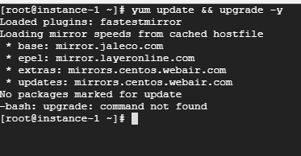

1. Install open jdk version 1.7 -- yum install java-1.7.0-openjdk -y

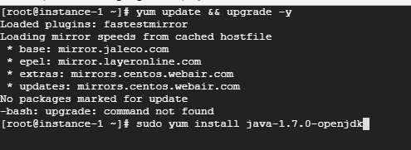

1. Install zip unzip for compression and extraction -- yum install zip unzip

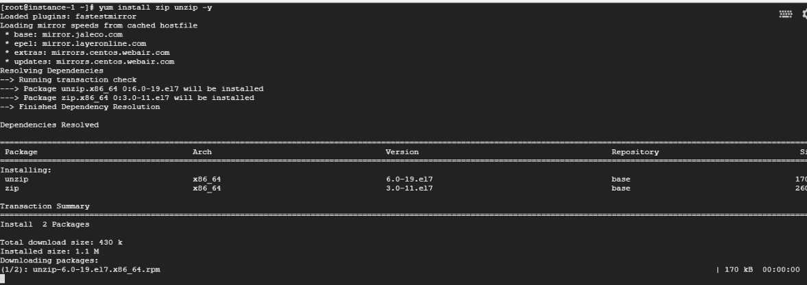

1. Install sdkman -- curl -s https://get.sdkman.io | bash

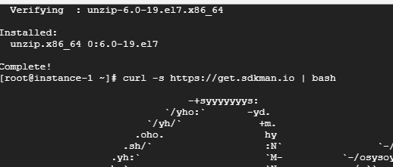

1. Verify SDKMAN is installed – sdk help

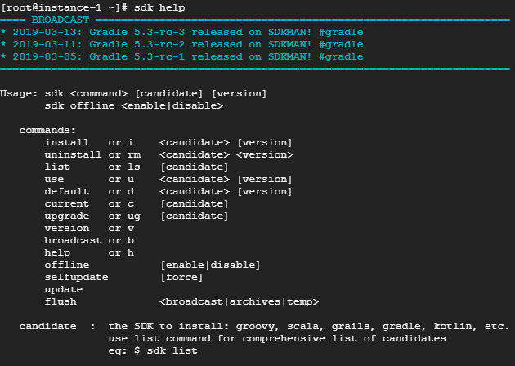

1. Install Spring Boot -- sdk install springboot